Practical No. 3
Aim : Phase Shift Keying (PSK) using any open-source simulation software

Name : Danish Altaf Solkar | Class : CO - B
Enrolment no. : 24111590805 | Batch : 2

Code :-
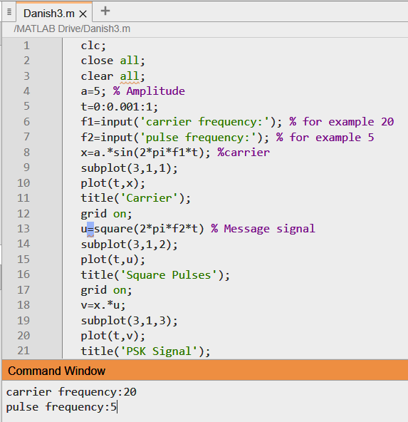
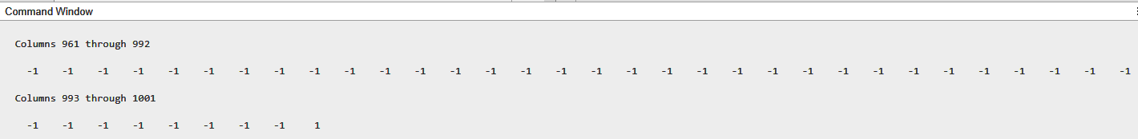

OUTPUT :-
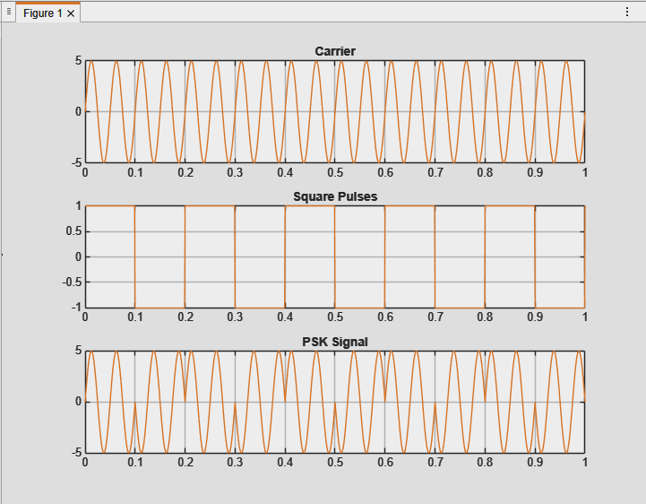

Process related  (15) | Product related  (10) | Total Marks  (25) | Signature

